ASJID TAHIR  
P19-0085

DATABASE- SYSTEMS LAB

LAB # 07:

**Sub-Queries:**

SELECT * FROM THEMEPARK;

SELECT AVG(TICKET_PRICE) FROM TICKET;

SELECT TICKET_NO, TICKET_TYPE, TICKET_PRICE FROM TICKET WHERE TICKET_PRICE >= (SELECT AVG(TICKET_PRICE) FROM TICKET);

SELECT PARK_CODE, SUM(LINE_QTY) FROM SALES_LINE NATURAL JOIN TICKET GROUP BY PARK_CODE HAVING SUM(LINE_QTY) >

(SELECT AVG(LINE_QTY) FROM SALES_LINE);

SELECT TICKET_NO, PARK_CODE, TICKET_PRICE

FROM TICKET

WHERE TICKET_PRICE > ALL (SELECT TICKET_PRICE FROM TICKET

WHERE TICKET_TYPE = 'CHILD');

SELECT TICKET_NO, TICKET_PRICE,

(SELECT AVG(TICKET_PRICE) FROM TICKET) AS AVGPRICE,

TICKET_PRICE - (SELECT AVG(TICKET_PRICE) FROM TICKET) AS DIFF

FROM TICKET;

SELECT TRANSACTION_NO, LINE_NO, LINE_QTY, LINE_PRICE

FROM SALES_LINE SL

WHERE SL.LINE_QTY > (SELECT AVG(LINE_QTY)

FROM SALES_LINE SA

WHERE SA. TRANSACTION_NO = SL. TRANSACTION_NO);

Exercises:

--LAB EXERCISES

--EXERCISE NO 1:

SELECT DISTINCT EMP_FNAME, EMP_LNAME FROM EMPLOYEE NATURAL JOIN HOURS WHERE HOUR_RATE > (SELECT AVG(HOUR_RATE) FROM HOURS);

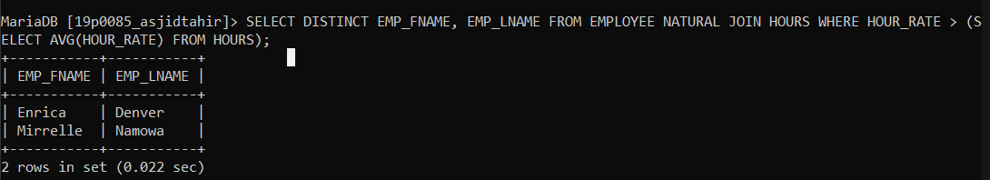

--EXERCISE NO 2:

SELECT EMP_FNAME,EMP_LNAME,DATE_WORKED,(SELECT AVG(HOURS_PER_ATTRACT) FROM HOURS) AS AVERAGE, HOURS_PER_ATTRACT -

(SELECT AVG(HOURS_PER_ATTRACT) FROM HOURS) AS DIFFERENCE FROM EMPLOYEE NATURAL JOIN HOURS;

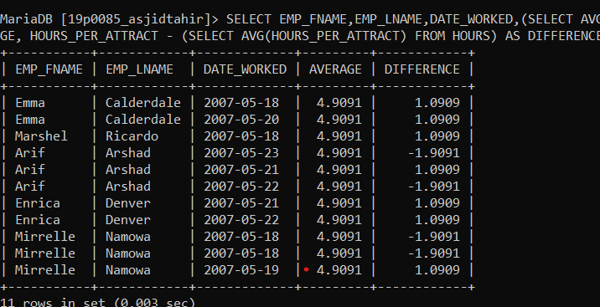

--EXERCISE NO 3:

SELECT ATTRACT_CAPACITY FROM ATTRACTION WHERE ATTRACT_CAPACITY <= (SELECT AVG(ATTRACT_CAPACITY) FROM ATTRACTION);

